Salesforce App / Application
- A Salesforce Application (App) is a collection of groups of tabs that work together to provide specific functionality to users.
- Salesforce provides several standard apps such as: Sales, Call Center (Service), Marketing, Community

Types of Salesforce Applications
Custom Apps
- Created by users based on business needs
- Can include custom objects, tabs, and features
Console Apps
A Console App is a tab-based workspace that improves productivity by allowing users to manage multiple records on a single screen.
💡 Features
- Open multiple records at once
- View related records using subtabs
- Reduce time spent on navigation (less clicking and scrolling)
- Quickly create, update, and access records

API Name for a Field
The API Name of a field is its technical identifier used internally in Salesforce. It is mainly used in coding, integrations, and automation processes.
✅ Key Points
Used in:
- Apex code
- SOQL queries
- APIs (REST/SOAP)
- Formula fields

APP Assignment

Create an app in salesforce simulating the functionalities of a Bank (App Label: “Bank”).
Step 1: Setup In Quick Find Type App Manager Click App Manager
Step 2: Click New Lightning App
Step 3: App Details & Branding
Fille the details
App Name, Developer Name & Description
Click Next
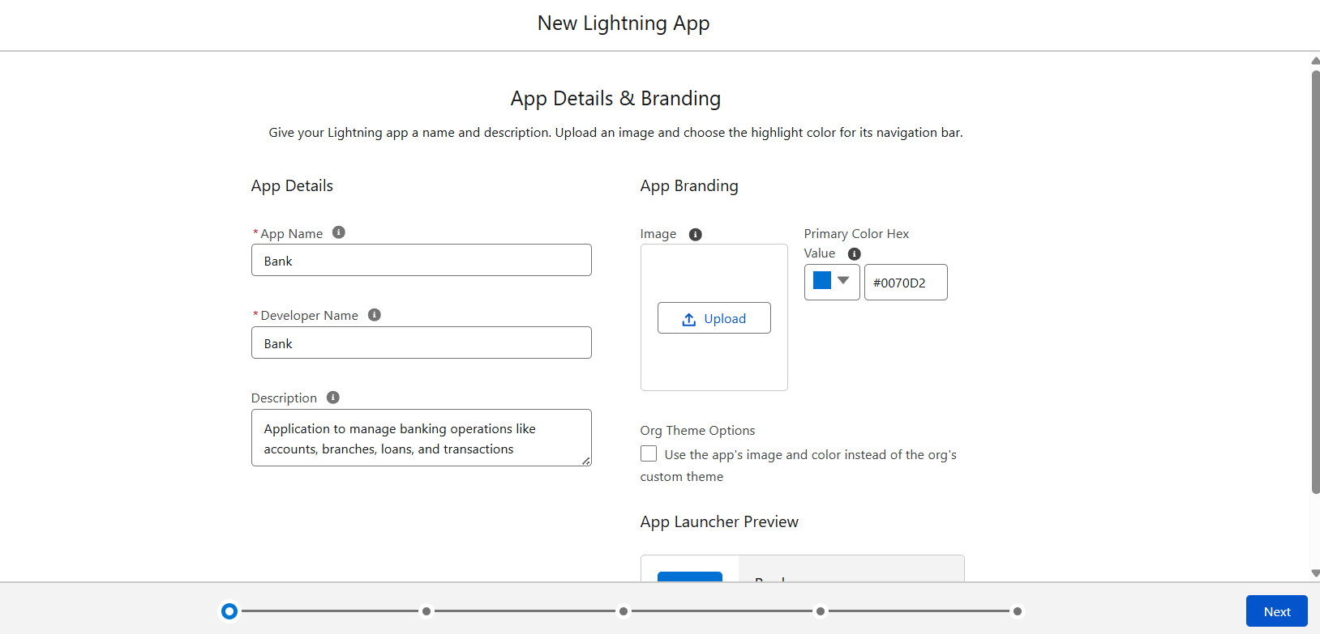

Step 4: Navigation Style (use standard) Click Next
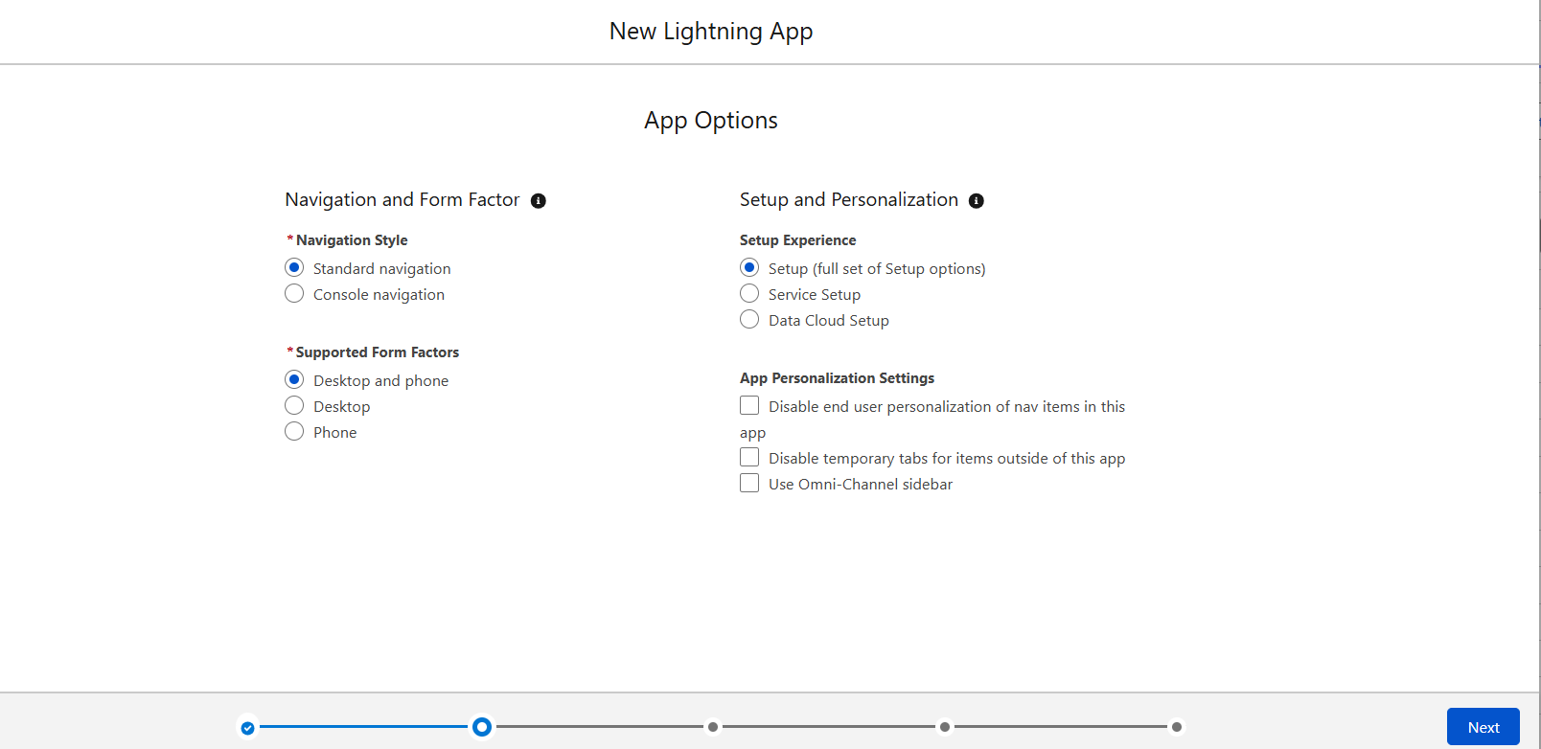

Step 5: Utility Items (Skip for now)
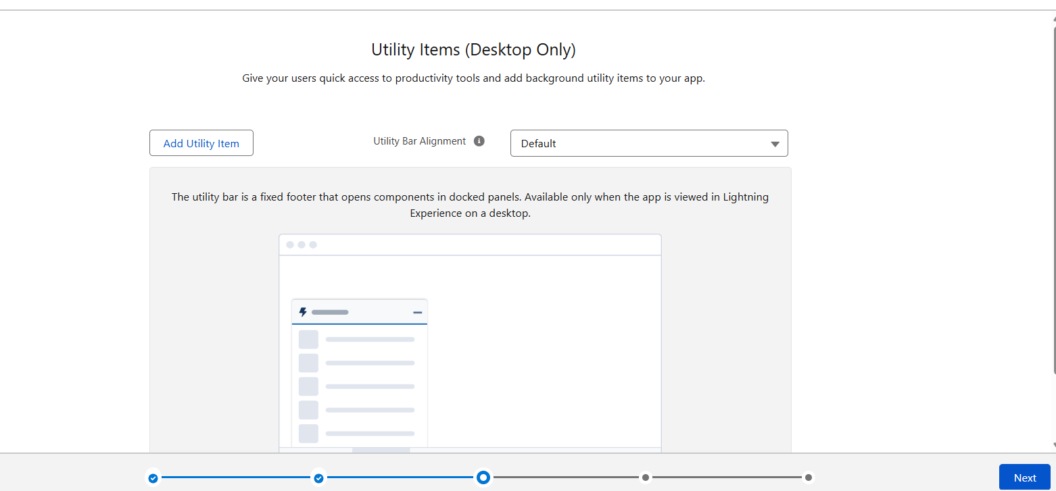

Step 6: Navigation Items (Don’t add items now, we will add after creating objects)
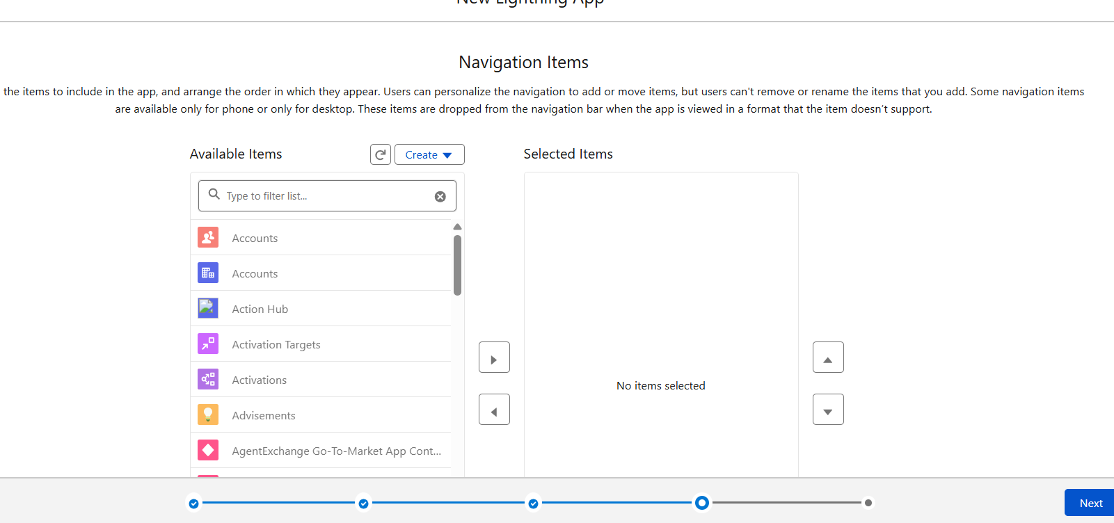

Step 7: User Profile
Select Profiles (System Administrator) Click on save and Finish
